Company: |  |  |  |  |  |  | Contact: |  |  |  |  |  |  |  |  |  |  |  |  | Date:
PROCESSING CONDITIONS |  |  |  |  |  | Part Description:
Resin Type: |  |  |  |  |  | Melt Index #: |  |  |  |  |  |  |  | Matl. Solids Density:
Total Shot Weight: |  |  |  |  | Screw RPM: |  |  |  |  |  |  | Back pressure: |  |  |  |  |  |  |  |  | Inj. Speed:
Screw recovery time: |  |  |  |  |  | Injection forward time: |  |  |  |  |  |  |  |  |  |  | Overall cycle time:
Melt decompression distance: |  |  |  |  |  |  | Melt temperature: |  |  |  |  |  |  |  |  | How measured?
Barrel Temp Settings:
(Set point): | Rear Zone #4 |  |  |  |  |  | Zone #3 |  |  |  |  |  | Zone #2 |  |  |  |  |  | Front Zone #1
(Actual): | Rear Zone #4 |  |  |  |  |  | Zone #3 |  |  |  |  |  | Zone #2 |  |  |  |  |  | Front Zone #1
MACHINE DATA |  | Make: |  |  |  |  |  |  | Model: |  |  |  |  |  |  |  |  | Serial No.:
Inj. Capacity (PS): |  |  |  | Inj. Unit #: |  |  |  |  |  |  | Clamp Tonnage: |  |  |  |  |  |  |  | Max. RPM:
Screw Diameter: |  |  | L/D Ratio: |  |  |  |  |  |  | Stroke of Injection Unit: |  |  |  |  |  |  |  |  | Max. Inj. Pressure:
Existing Screw Design: |  |  |  |  |  |  |  | Tip Design: |  |  |  |  |  |  | Screw & Barrel Matl:
OBJECTIVES:
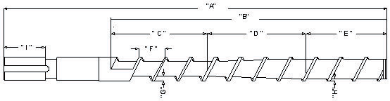
A) | B) | C) | D) | E)
F) | G) | H) | I)

Thank you for completing our Injection Screw Design Questionnaire.
Please email to neil@coopertech.com.

