|  |  |  |  |  |  |  |  |  |  |  |  |  |  |  |  |  |  |
| --- | --- | --- | --- | --- | --- | --- | --- | --- | --- | --- | --- | --- | --- | --- | --- | --- | --- |
| Company: | | | | | | | | | | | | | Date: | | | | |
| Address: | | | | | | | | | | | | | | | | | |
| Contact: | | | | | | Email: | | | | | | | | | | | |
| Phone: | | | | | | Fax : | | | | | | | | | | | |
| **Extruder Mechanical Information** | | | | | | | | | | | | | | | | | |
| OEM: | | | | | | | | | Dia: | | | | | X | L/D: | | |
|  | | | | | | | | | | | | | | | | | |
| Drive Motor Power: | AC  or DC  ?:  Motor RPM: | | | Gearbox ratio:    **: 1** | | | | | | Max Screw RPM:  **0 to**        Max | | | | | | Max Motor Amps: | |
|  | | | | | | | | | | | | | | | | | |
| Melt Pump?  Y  N | | **→** | If Yes then what is the Suction Bar? | | **→** | | If No, then what is the Max Head Bar? | | | | | Screen Changer?  Y  N | | | | | Screw Cooling?  Y  N |
|  | | | | | | | | | | | | | | | | | |
| Grooved Feed?  Y  N | | **→** | If Yes, please describe the Groove Details.  # of grooves:  W       x D       x L | | | | | | | | Does the barrel insert through the Feed Block? Y  or N | | | | | | |
|  | | | | | | | | | | | | | | | | | |
| Vented Barrel?  Y  N | | | If Yes, then location from back of Feed Opening to centerline of vent hole?        mm | | | | | | | | | | | | | | |
|  | | | | | | | | | | | | | | | | | |
| Feed Hole Size  W       x L       or Diameter | | | | | | | | Feed Mechanism  Hopper  Crammer  Stuffer | | | | | | | | | |
|  | | | | | | | | | | | | | | | | | |
| Barrel Cooling – Water  or Air  Please submit current Barrel Zone Temperature Settings:  1:       2:       3:       4:       5:       6:       Die: | | | | | | | | | | | | | | | | | |

Feed End Discharge End

**Current Screw Design:**

Conventional  Mixing  Barrier  Other

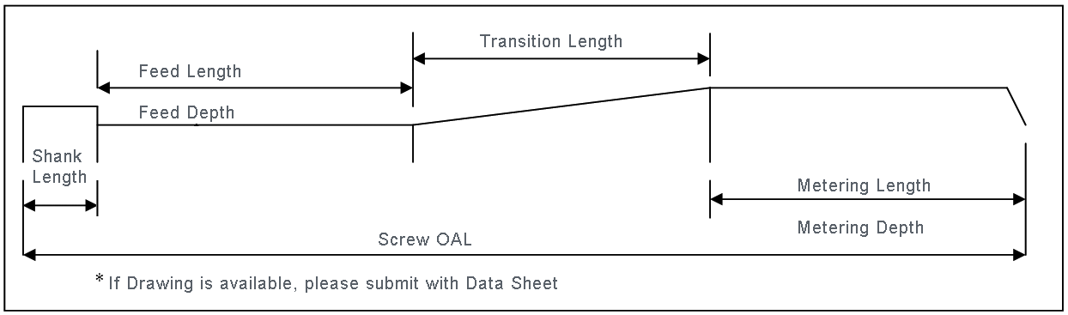

|  |  |  |
| --- | --- | --- |
| Feed Length: | Feed Depth: | Transition Length: |
| Metering Length: | Metering Depth: | Screw OAL: |

|  |  |  |  |  |  |
| --- | --- | --- | --- | --- | --- |
| Sheet | Pipe | Blowmoulding | Profile | Wire & Cable | Pelletizing |
| Compounding | Cast Film | Blown Film | Fiber | Other: | |

**Resin Data**

|  |  |  |  |  |  |
| --- | --- | --- | --- | --- | --- |
|  | **Application 1** |  | **Application 2** |  | **Application 3** |
| Materials Used: |  |  |  |
| Resin Numbers ** |  |  |  |
| ** *If resin numbers are unknown, please provide samples of materials to be processed. See attached document for details.* | | | | | |
| Manufacturer: |  |  |  |  |  |
| Regrind % |  |  |  |
| Regrind Bulk Density |  |  |  |
| Additives Detail  (Type, % etc) |  |  |  |
|  | * If Colour, is it Liquid  / Concentrate  ? | | | | |
| Resin Drying? | °C/Hrs |  | °C/Hrs |  | °C/Hrs |

**Current Performance (Process Snapshot)**

|  |  |  |  |  |  |
| --- | --- | --- | --- | --- | --- |
| Current Output? | Kg / Hr |  | Kg / Hr |  | Kg / Hr |
| @ Melt Temp? | °C | °C | °C |
| @ Screw RPM? | RPM | RPM | RPM |
| @ Motor Amp? | Amps | Amps | Amps |
| @ Head Pressure | Bar | Bar | Bar |

|  |  |  |  |  |  |
| --- | --- | --- | --- | --- | --- |
| **Desired Performance Requirements** | | | | | |
| Desired Output Range | Kg/Hr |  | Kg/Hr |  | Kg/Hr |
| @ Melt Temperature | +/- 10 °C |  | +/- 10 °C |  | +/- 10 °C |
| @ Pressure Stability | +/- BAR |  | +/- BAR |  | +/- BAR |

What problems brought about the need for this new screw design? (Throughput. Melt Temperature, Stability, Mixing etc)

How will you measure the Melt Temperature?

Hand Held Melt Pyrometer  Melt Probe Instrumentation  Are they calibrated? Y  N

Where will the measurements be taken?

Before Screen Changer  After the Die  Other, please specify:

What goals do you need to achieve with this new screw design?

Thank you for completing our Extruder Screw Design Questionnaire. Please email to [neil@coopertech.com](mailto:neil@coopertech.com).